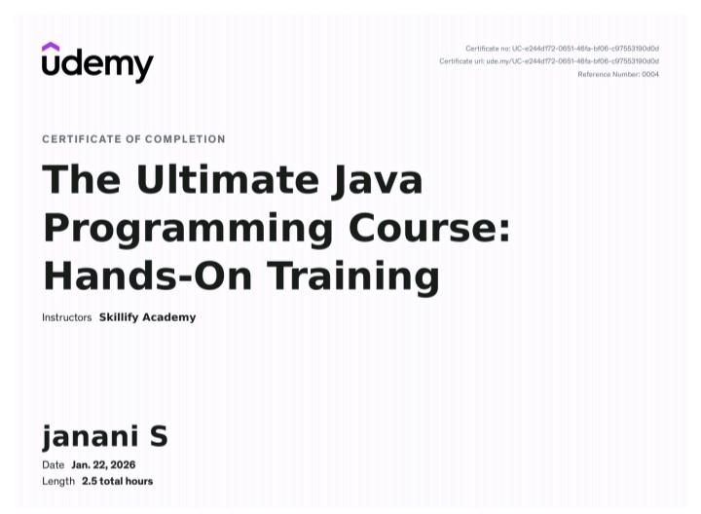
ûdemy
Certificate no: UC-e244d772-0651-46fa-bf06-c97553190d0d Certificate url: ude.my/UC-e244d172-0651-46fa-bf06-c97553190d0d
Reference Number: 0004
CERTIFICATE OF COMPLETION
The Ultimate Java Programming Course: Hands-On Training
Instructors Skillify Academy
janani S
Date Jan. 22, 2026
Length 2.5 total hours

